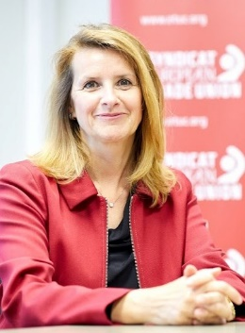
Isabelle Schömann, elected Confederal Secretary at the ETUC Congress in 2019, heads ETUC policy on democracy at work with a focus on workers’ information, consultation and participation, on legal affairs with a focus on trade unions, workers’ and human rights, in charge of the ETUCLEX, on gender equality, on single market and competition, on industrial policy, and on digitalisation with a focus on artificial intelligence in the world of work.
Isabelle is a member of IGMetall (Germany) and of FGTB (Belgium). As ETUI researcher, she was member of the ETUI staff representation and ETUI works council.
Between 2016 to 2019, Isabelle was principal adviser to the Regulatory Scrutiny Board of the European Commission, that advises the College of Commissioners on EU legislation on the basis of quality control of impact assessments and evaluations.
As senior researcher at the European Trade Union Institute (ETUI) from 2002 to 2016, Isabelle was in charge of European social dialogue and European and comparative labour law, fundamental social rights, workers’ participation, with a focus on the impacts of the 2008 financial and economic crisis on workers' rights and on the impacts of European Better Regulation agenda on labour rights: https://www.etui.org/fr/content/search?keys=sch%C3%B6mann
Former research fellow at the Berlin Social Science Center ( WZB - Germany) from 1995 to 2022, Isabelle holds a postgraduate degree in social and labour law from the Sorbonne University in Paris (France).

