Impact of the energy price crisis in EU Member States and trade union actions
Background
Gas and electricity prices have skyrocketed in Europe over the last year, along with oil and coal. This energy price crisis is the result of a combination of several factors:
- Mid 2021, the strong rebound in consumption and economic activity resulting from the ease of COVID19 measures lead to a significant increase in gas demand, especially in Asia. This surge in demand resulted in a first increase of gas and electricity prices in Europe.
- In parallel, a particularly cold winter in Europe in 2021 combined with a lower than usual availability of wind and solar energy resulted in lower gas storage and further increased energy prices.
- A lower production of liquefied natural gas worldwide in 2021, due to a series of unplanned outages further reinforced the tensions on the markets.
- To a lesser extent, increases in the price of carbon emission allowances of the European Emission Trading System has also contributed to the rise in electricity prices.
- The shutdowns of 32 out of the 56 French nuclear plants due to routine maintenance or defects further increased tensions on the electricity market since end of 2021.
- In 2022, geopolitical tensions around Nord Stream 2 and the Russian invasion of Ukraine further contributed to exacerbate the energy price crisis, by adding even more volatility and uncertainty in the oil and gas markets. The fact that Russia decided to reduce its gas supply to Europe and to use it as a weapon to blackmail European countries also contributed greatly to skyrocketing prices.
- In addition, extreme weather events, directly resulting from climate change, further increased the stress on energy infrastructures during the summer 2022. Heat waves have indeed boosted electricity demand while droughts resulted in the shutdown of many hydro and nuclear plants across Europe.
As a result, gas prices have risen by more than ten times compared to the pre-pandemic situation, as illustrated in the figure below.
Evolution of Dutch TTF gas prices since October 2020
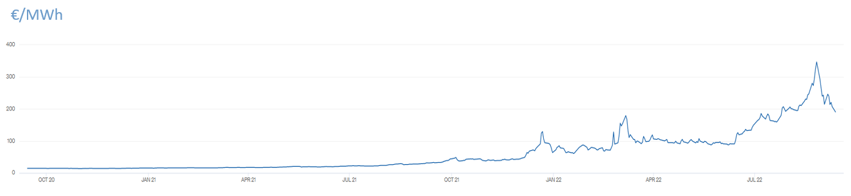
Source : https://www.theice.com/products/27996665/Dutch-TTF-Gas-Futures/data?marketId=5429405&span=3

The increases in gas prices are causing equivalent rises on electricity prices due to the current functioning of the EU electricity market. In Europe, to determine the price of electricity on the wholesale market, the so-called "merit order" principle is applied. The various producers bring their capacities to the market to meet the demand. In the vast majority of cases, it is a coal or gas-fired power plant that is called upon last to supply the MW needed to balance supply and demand. The merit order is that the price paid to this plant - covering its production costs, including CO2 emission rights and its margin - is paid to all producers, even if their own costs are lower. This means that the marginal costs of the last producer (in this case gas-fired power plants) determines the cost of electricity on the wholesale market, even though part of the electricity is produced at a much lower cost (e.g. the part that is produced through renewables, nuclear, biomass,…).
Those increases in energy prices have considerably reduced the purchasing power of EU citizens and have increased energy poverty risks, especially among low- and middle-income households. At the same time, this energy inflation puts at risk the viability of many companies and therefore threatens the jobs of working people.
The war in Ukraine also highlighted EU’s extreme dependence on Russian imports when it comes to oil, coal and especially gas, forcing Europeans to considerably reduce their imports coming from Russia. The figures below show the situation regarding gas imports before the Russian invasion of Ukraine and after. Before the crisis, almost 40% of the gas imported to Europe came from Russia. This percentage has been reduced to 9% today. The EU compensated the reduction in Russian gas by increasing imports from other partners, particularly through LNG suppliers, but that diversification of supplies comes at a high financial cost for European consumers.
Overview of physical gas flow to Europe
October 2021 September 2022
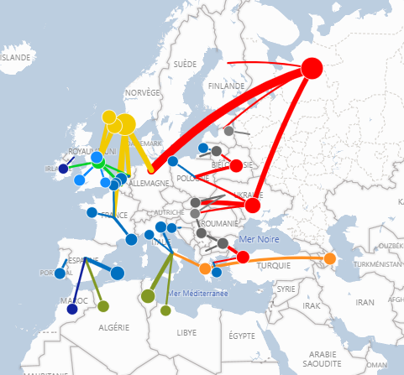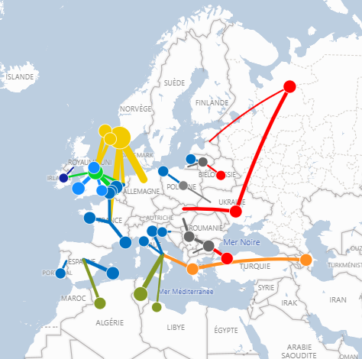
Source ENTSOG https://gasdashboard.entsog.eu/

Actions taken by Member States so far
Member States were the first ones to take action in an attempt to mitigate the impact of skyrocketing energy prices on their citizens. The table below – done by the European think tank Bruegel – summarizes the different policy measures taken by national authorities so far in light of the energy price crisis. A detailed overview of all measures taken by country is also available in the same article from Bruegel.

Table classifying the measures taken since September 2021 into seven types of responses
(last updated on 08/08/2022)

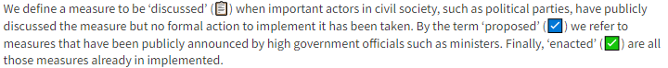
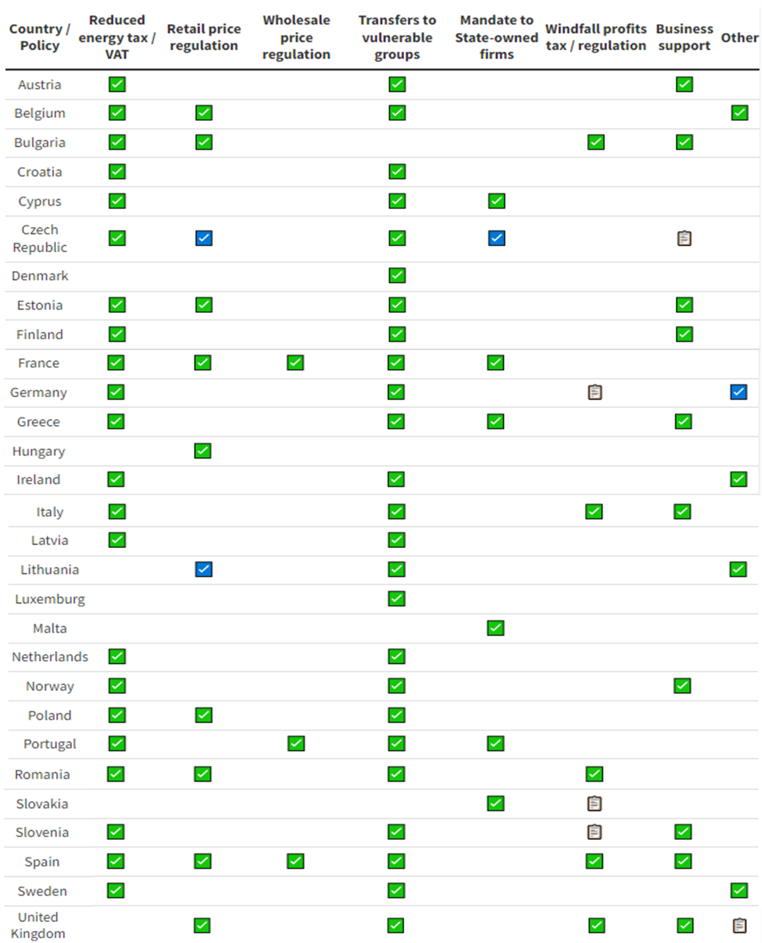
Source : Sgaravatti, G., S. Tagliapietra, G. Zachmann (2021) ‘National policies to shield consumers from rising energy prices’, Bruegel Datasets, first published 4 November 2021, available at https://www.bruegel.org/dataset/national-policies-shield-consumers-rising-energy-prices.

Actions taken by the European Commission so far
To answer this energy price crisis, the European Commission already took several initiatives :
- On 13 October 2022, the Commission released a first Communication titled Tackling rising energy prices: A toolbox for action and support, which provides a list of measures that Member States can take to ease the burden on consumers in the short term.
- On 8 March, following the Russian invasion of Ukraine, the EU Executive branch adopted another Communication called REPowerEU: Joint European action for more affordable, secure and sustainable energy with the aim of reducing considerably the EU’s dependence on Russian gas imports and mitigating the energy price crisis.
- A third Communication was published on 23 March Security of supply and affordable energy prices: Options to mitigate high energy prices with common gas purchases and minimum gas storage obligations to further detail the measures of REPower EU and to consolidate the list of measures available to Member States.
- End of April, ACER – the European Union Agency for the Cooperation of Energy Regulators – published its Final Assessment of the EU Wholesale Electricity Market Design in the light of the current energy crisis.
- On 18 May, the Commission published a consolidated version of its REPowerEU strategy, further detailing measures to achieve energy savings, diversify energy supplies and accelerate the roll-out of renewable energy to replace fossil fuels in homes, industry and power generation, as well as a communication on Energy markets announcing possible reforms for the long term improvement of the Electricity Market Design.
- Following record spike in energy prices in August and ahead of the extraordinary meeting of the Council of Energy ministers, Ursula Von Der Leyen tabled a series of proposals to tackle rising energy prices. Among those proposals: A binding target for reducing electricity demand, a cap on the revenues of certain electricity producers and on the price of Russian gas, and the redistribution of super-profits made by fossil fuel companies.
- Following the discussion in the EU Energy Council on 9 September and the guidance received from Member States, Ursula Von Der Leyen used the State of the European Union on 14 September to propose an emergency market intervention to reduce bills for Europeans. As part of this emergency intervention, the Commission proposes exceptional electricity demand reduction measures (obligation to reduce electricity consumption during peak hours, aim to reduce overall electricity demand) as well as measures to redistribute the energy sector’s surplus revenues to final consumers (temporary revenue cap on inframarginal electricity producers and temporary solidarity contribution on excess profits from oil, gas, coal and refinery sectors, those revenues collected by Member States to be used to help energy affected consumers and companies, allow below cost regulated electricity prices and expansion of regulated prices to cover SMEs). The Commission announced it will also further reflect on the idea of a cap on gas prices and tools to improve liquidity on the market for energy utilities, but those were not part of the emergency measures presented.

ETUC key demands and position
On 22 June 2022, ETUC Executive Committee adopted an ETUC resolution that provides recommendations in light of the energy price crisis. Among the key demands, ETUC asks policy makers to :
- Rapidly and drastically reduce EU’s dependency to Russian fossil fuels imports while working towards achieving European Green Deal’s objectives. In the short term, this means diversifying EU’s energy supplies, ensuring sufficient gas storage, and adopting a more coordinated purchasing policy. This also means that the EU should accelerate the roll out of its European Green Deal on the basis of a strong just transition legal framework, notably when it comes to energy efficiency, energy savings, circular economy and renewable energy.
- In parallel, policy makers need to speed up and scale up policy measures supporting most affected consumers, workers and companies as well as take urgent measures to mitigate energy price crisis. ETUC demands, among others, that :
  - the EU introduces a cap on energy prices
  - the EU decouples the electricity price setting mechanism from gas prices
  - the EU develops a tax on the windfall profits made by energy companies in light of the energy price crisis
  - Member States put in place additional short-term support to affected people, for example through energy vouchers targeted at low- and middle-income households (particularly those having flexible energy contracts), extension of social tariffs, temporary reduction of energy VAT for households most affected, etc.
  - In case of oil and gas shortages or loss of competitiveness due to high energy prices that would force companies to reduce or stop their activities, the EU should be ready to reactivate and strengthen solidarity mechanisms (such as SURE) to support short time work schemes and workers that would be temporarily laid-off.
  - The Commission should also provide sufficient flexibility when it comes to state aid supporting undertakings in difficulty due to higher energy costs. However, such state aid should be conditional to strong social and environmental criteria.
- ETUC also highlights that the current crisis should be a wakeup call for policy makers to question the liberalisation of the EU energy market and to rethink its current functioning. EU policy makers should revise and improve the design of the energy market, notably when it comes to price setting mechanisms, emergency mechanisms to regulate energy prices, increased consumer rights in energy contracts, reinforcement of public service obligations, the promotion of public ownership where relevant, the creation of a right to energy and the fight against energy poverty.
- ETUC also highlights the need for an EU strategic autonomy aiming at (1) reducing EU vulnerability in a wide range of domains including in energy supply and renewable energy, as a (2) sustainable, inclusive and regulated alternative to address disruptive crisis situations that the EU faces.

Feedback from national affiliates
Members of the Sustainable Development Committee were asked to provide their feedback and national perspective on the following questions :
- Which sectors are the most affected by the current energy price crisis in your country?
- Can you please explain how those sectors are impacted?
- Can you provide examples of companies that have temporary shut down their activities due to the energy price crisis?
- Are you aware of any trade union action/campaign organised in relation to the energy price crisis in your country (at national, regional, sectoral or company level)?
- Have your trade union organisation formulated a list of demands to your national government to support workers? What are those main demands?
- How do you evaluate the response given by your government so far to cushion the impact of the energy price crisis on consumers and workers?
- What else should be implemented according to you?
Belgium
According to FGTB-ABVV, most impacted sectors are chemistry, textiles and textile care, glassmaking, manufacture of bricks and tiles, trade and non-market sector. Those sectors are affected through the increase of energy price but also through the general inflation of raw material. A reduction of demands and sale is also affecting them. All this already forced some sectors to use temporary unemployment. So far, the measures taken by the Belgian government are not sufficient according to trade unions. FGTB-ABVV is actively campaigning to protect workers purchasing power and to find strong and adequate solutions to the crisis and has formulated a series of demands. More details about FGTB-ABVV campaign and demands can be found in Annex I as well as concrete examples of companies affected.
CSC shares similar views on the situation in Belgium and provided detailed feedback for each of its sectoral branch with a full analysis and concrete examples. Those detailed feedbacks can be found in Annexes II.
France
According to CFDT, most impacted sectors are steel, metallurgy, cement, chemicals, paper and cardboard, as well as agri-food and transport. CFDT is following closely the discussions related to the energy price crisis in close coordination with other TU organisations and NGOs. It is actively involved in the development of the French National Energy and Climate Plan as well as on the “plan de sobriété” that will need to be implemented by companies by 2024. The detailed feedback from CFDT with concrete examples of companies affected and list of recommendations can be found in Annex III.
Poland
KADRA welcomes the analysis of the briefing note when it comes to describing the situation on the gas and electricity market. However, it points out that the energy price crisis is not only limited to that. Indeed, the security of supply and the price of solid fossil fuels such as oil and coal is also causing great risk to the economy and affecting millions of EU citizens. KADRA asks that the EU does not only focus on resolving gas and electricity issues but also pay attention to the supply and price of coal which remains a very important energy source for EU citizens, especially in Poland and other Eastern European Countries.
When it comes to the sectors most affected by the energy price crisis in Poland, KADRA identify the following ones : steel industry/coke industry, ceramic industry, fertilizer producers, food industry, cement industry, energy sector (including domestic coal mining and gas mining). When it comes to trade union actions, KADRA is actively campaigning to minimize the increase in energy prices for citizens. KADRA is also looking for collective bargaining opportunities for employees in the gas, coal, electricity and heat production sectors to improve employee wages. More detailed feedback, concrete examples and demands from KADRA can be found in Annex IV.
Spain
UGT believes that sectors are affected by the energy price crisis in one way or another but energy intensive sectors are the hardest hit. Among the most affected are mining, metallurgy, the wood and paper industry, basic chemicals or the manufacture of rubber and plastics products. UGT estimates that the Spanish government has taken action that is going in the right direction but that more could be done. UGT has formulated concrete demands to improve the situation and has recently launched a campaign entitled higher wages, lower prices and more equality. More detailed information about UGT demands can be found in Annex V.
The Netherlands
According to FNV, all sectors have to deal with rising energy prices as well as rising raw material prices in the Netherlands. Energy-intensive sectors (e.g. metal and chemical industry, brick production, transport, greenhouse horticulture, bakeries, saunas and swimming pools, call centers) suffer the most from the rising prices. SMEs are particularly affected compared to large industrial companies as it is more difficult for them to pass on the cost to consumers. They also have less financial buffer and their capacity to negotiate with suppliers is more limited. FNV details several measures that have been taken by the Dutch government to cushion the impact of the energy price crisis on consumers. Those measures are a step in the right direction but were taken far too late. FNV believes that the catch up needs to happen faster and be more focused. More structural solutions are also needed. In Annex VI, FNV provides concrete examples of companies affected by the energy price crisis and provides more details on its key demands.

Austria
For ÖGB, all sectors are affected by the energy price crisis and especially energy intensive industries (steel, chemical, paper, etc.). A few Austrian companies already reduced or stopped their production. Others are facing high uncertainty due to unclear legal frameworks and high investment Costs for gas substitutes and new machines/combustion systems. ÖGB is not satisfied with the measures taken by the government so far. ÖGB organized several actions, notably a strike on 17 September 2022. It also made several proposals to tax excess profits and establish an energy price cap. Annex VII provides concrete examples of companies affected, more details about ÖGB actions and demands and a more thorough analysis of the government action.
Denmark
Based on the feedback received from IDA, it seems Denmark is a bit less affected by the energy price crisis than other countries. According to IDA, the sector that has been affected most is the retail sector. There does not seem to have many cases of companies temporary shutting down due to the energy price crisis. IDA is also generally positive about the answer that has been given by its national authorities so far but has additional demands. Annex VIII provides more details.

