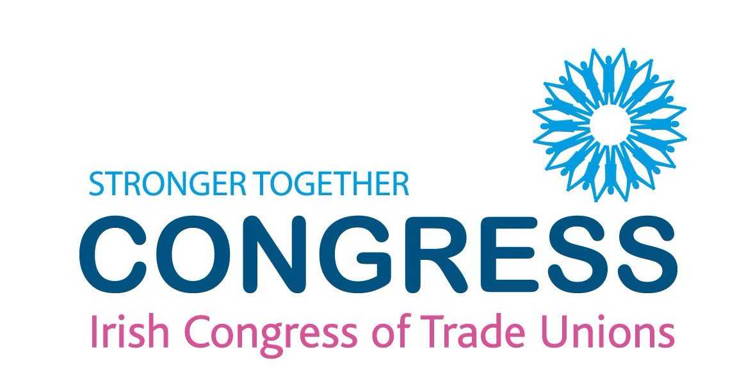

A Temporary Wage Compensation Scheme

19 March 2020

- The Irish Congress of Trade Unions (ICTU) is calling on the Government to establish a temporary wage compensation scheme in response to the Covid-19 outbreak.
- In any recession, maintaining employment contracts between employers and employees is the most important factor in ensuring any labour market recovery.
- Employees facing substantial or total wage loss during this crisis need support and the evidence is clear that when such support is provided through their employer, these employees experience significantly improved employment outcomes post-crisis and beyond.
- Without support, employees face the prospect of unemployment and will require the support of the state benefits system. Similarly, employers will face labour and skills delays and shortages as they attempt to readjust post-crisis.
- A scheme agreed between employers, trade unions and government in Denmark provides a template for how such income support can be supported by labour market stakeholders.
- For a three-month period, the Danish Government has agreed to pay 75% of employees’ wages, employers have agreed to pay the remaining 25% up to a maximum of the average industrial wage rate. For their part, employees have agreed to take 5 days of holidays during the crisis.
- If such a scheme was introduced in Ireland it should be be particularly targeted at companies who are economically affected as a direct consequence of Covid-19. It would also apply to firms that have been instructed by government to cease trading for the duration of the crisis. Companies would be required to demonstrate a significant sudden reduction in turnover (e.g. as officially verified by their audited accounts/accountants) and all eligible workers, i.e. full-time, part-time, temporary wold be included.
- This scheme would apply for a temporary period of three months only. This could be extended only by agreement with the national stakeholders following consultation or at sectoral and subsequently firm level.

The following table illustrates how this mechanism would apply in Ireland and the overall costings involved:

Annual gross wage | €40,000 | Gross weekly wage | €767.75
Weekly tax and PRSI | €159.75 | Net weekly wage | €608.00
75% government contribution to employment income (annualised) | €30,000 | Weekly government contribution to employment income | €575.82
 |  | Weekly government contribution minus weekly tax and PRSI for a worker on €40,000 | €416.07
25% employer contribution to employment income (annualised) | €10,000 | Weekly employer contribution to employment income | €191.64
Social welfare | €203.00
Weekly contribution minus tax/PRSI and social welfare | €213.07
Government contribution minus tax/PRSI and social welfare (12 weeks) | €2556.84
Scaled to 350,000 workers | €894.89 million | Gross cost | €1.75 billion

Mechanism for Payment
The Maternity Protection (Amendment) Acts 1994-2004 facilitates an employer paying the employee their full pay while the employee Maternity benefit due is rebated directly to the employer by the Department of Social Protection. In our view this could be replicated for the administration of such a ‘Temporary Compensation Scheme.’
Conclusion
- As set out earlier, when economies experience recession, schemes that maintain employee-employer relationships are most conducive to labour market recoveries.
- As we expect this disruption to be short-lived, exposing the state benefit system to a significant and rapid influx of applicants is not desirable.
- A scheme such as that outlined above represents a significant commitment by the Irish Government but it should be considered an investment in the pace of economic recovery that can be expected after this crisis recedes.

General Secretary: Patricia King
31-32 Parnell Square, Dublin 1, Ireland Tel: +353 1 889 7777 Fax: +353 1 887 2012
Email: congress@ictu.ie Web: www.ictu.ie Affiliated to the European Trade Union Confederation

