CMKOS position regarding the COVID-19 crisis

- We demand a comprehensive solution to the situation.
- Now, protecting the health and lives of the population is a priority. Masks, respirators and other protective equipment are missing in Czechia. People are afraid to go to work or even to do groceries.
- It is clear that the economy will go down. There’s a threat of halt. The fundamental requirement is to maintain the purchasing power of the population. We need an employment package.
- We need massive state support for businesses without income. Ideally, we would like to get 100% wage compensation. However, people themselves should know, recognize and realize that the situation is serious.
- Interest-free loans from the state for companies are required.
- According to Czech legislation, in the state of emergency the state should compensate the costs incurred by this situation to natural and legal persons. But it should also close schools and mandate work to maintain critical infrastructure.
- The issue of state debt is important. We need to unblock the state deficit in this situation. Parliament should unblock the deficit in relation to the state budget also in terms of the percentage of debt to GDP.
- This is probably not in line with EU rules, so it is essential that the EC clearly declares that it is repealing these rules for a certain period.
- It is also necessary to maintain the liquidity of the population. We recommend not to remit dividends from Czechia for a given period.
- We recommend stopping mortgage repayments, e.g. until the end of 2020 (in Czechia it amounts to almost 1% of GDP).
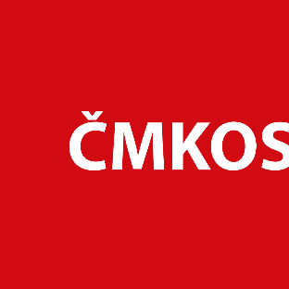
- We demand state loans for individuals, legal entities and self-employed persons.

