**Annex**

*This annex contains considerations that are relevant to the debate in the EU; the trade unions in MERCOSUR have developed their own annex focusing on issues that pertain to their region.*

**Incidence of labour violations in MERCOSUR countries**

The incidence of these violations unfortunately remains high in the region and in certain sectors in particular, as identified by the Commission’s own impact assessment (2021):

- cases of forced labour, and more specifically debt bondage and exploitation of indigenous populations (especially in the Chaco region);

- poor health and safety and working conditions in the mining sector;

- weak government presence and low investment in education are conducive to child labour, which remains a persistent challenge, especially in the Nordeste in Brazil.

This despite ILO programmes that have yielded some positive results and must continue to support efforts to address these violations.

Moreover, the ITUC Global Trade Union Rights Index 2025 finds that in [Brazil](https://www.ituc-csi.org/brazil) and in [Argentina](https://www.ituc-csi.org/spip.php?page=legal_info&cc=ARG&lang=en) systematic violations of trade union rights occur and the situation has deteriorated under the government of Mile; in [Paraguay](https://www.ituc-csi.org/paraguay) there are regular violations of trade union rights – the rights may exist but there are no adequate protections; [Uruguay](https://www.ituc-csi.org/uruguay) suffers from repeated violations.

**Possibility to strengthen the commitments in the agreement and their enforcement**

We understand that to meet the concerns raised, some improvements are being suggested including as part of the legal scrubbing, which we know it is actually not legally possible. Among the suggestions are a roadmap on child labour and implementation of ILO conventions or a (early) review of the TSD chapter and its enforceability as per article 18 of the TSD chapter.

Past experience with a roadmap shows the approach is ineffective. The EU attempted that approach with Vietnam, which has since ratified the OSH convention but is yet to ratify C98 and C87. The EU DAG statements ([2023](https://www.eesc.europa.eu/sites/default/files/files/eu-vn_dag_-_3rd_dag-to-dag_meeting_2023_-_eu_dag_statement_final.pdf) and [2024](https://www.eesc.europa.eu/sites/default/files/2024-06/euvn_dag_statement_final.pdf)) paint a very bleak picture of the situation in the country and show that Vietnam has not lived up to its promises despite the engagements in the roadmap.

Moreover, the European Commission's own legal analysis of a Single Entry Point complaint against Vietnam (systematic attacks on civil society and trade unions) concludes that there are no tools in the existing FTA to address these violations, which in practice make the TSD provisions in the FTA unenforceable. DG TRADE admits that the EU can only demand dialogue and cooperation and cannot force the implementation of ratified conventions in Vietnam. At the TSD committee with Vietnam, DG TRADE has settled with the government's offer to supply a briefing on labour law and progress on ratification, which is wholly inadequate.

Given these shortcomings of the Vietnam FTA and the Commission's own admission that the system therein is toothless, it would be unwise to accept that a roadmap would work in the case of the EU-MERCOSUR FTA, where the issue is not so much lack of ratification but ineffective implementation of ILO core conventions and in some instances violations of ratified conventions.

As for the review of the TSD chapter, this approach has already been used in the modernised EU FTAs with Chile and Mexico fairly recently. The problem is that a similar approach was adopted in the Canada FTA (2016) and despite the political will to complete this review as early as possible, the process has stalled. To date there has not been an 'early review' of the TSD chapter in CETA and with the new Canadian government the chances are even slimmer going forward.

Given these considerations, and the reluctance of the European Commission to carry out any improvements in TSD chapters once negotiated, there are no guarantees that this option will work in the case of MERCOSUR, where the TSD chapter would need to be reopened to include sanctions.

**Impact on employment**

The ETUC wants to know how many jobs will be created with the projected GDP growth and in which region/sector, also to disprove the suspicion this agreement has been negotiated for the benefit of one country and one sector (see the main beneficiaries below) and to allow us to explain to our members in all countries what they stand to gain from this agreement.

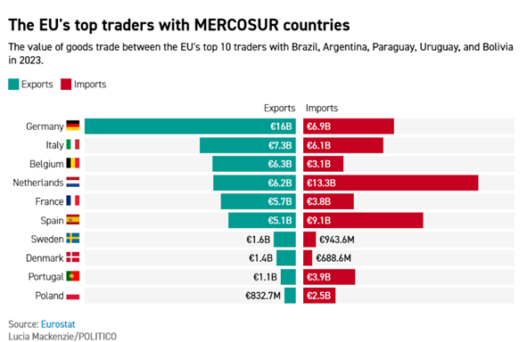

We know the methodology of standard impact assessments is heavily biased to demonstrate the benefits of trade. We demand greater clarity on this point of employment creation in a more granular way.

The 2021 impact assessment states

“*The impact on EU employment is proportionally much less significant given the bigger size of European labour markets. All sectors report employment changes under 1% under both scenarios, with only the sugar and beef sectors reporting job losses between 1.1 and 1.5% in the ambitious scenario.”*

The ETUC wants to know if these are quality jobs, relocation activity and substitution with worse working conditions. This is something trade unions in the agri-food sector are concerned about, jointly with employers.

The EU proposed tools to protect the livelihoods of the people who work in sectors that are set to lose out in this trade agreement are inadequate. As EFFAT - the European federation of food workers’ unions – has warned, the deal could lead to social dumping and unfair competition that would drive down working conditions in the EU, notably for 6 million people who work in the agricultural sector. There is no compensatory mechanism that would remedy this.