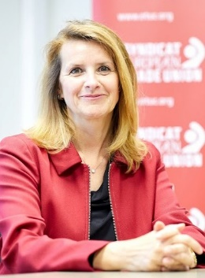
Isabelle Schömann, has been elected Deputy General Secretary at the ETUC 15. Congress in Berlin, in May 2023.
Isabelle heads ETUC policies on Democracy at Work with a focus on Workers’ Information, Consultation and Participation, on Legal Affairs with a focus on Trade Unions, Workers’ and Human Rights, the ETUC legislative, legal and litigation strategy (the ETUCLEX), on Gender Equality, on Single Market, and on Human Centric Digitalisation with a focus on Artificial Intelligence in the world of work.
Isabelle served as ETUC Confederal Secretary between 2019 to 2023. Key achievements in setting and implementing ETUC agenda materialise in her leadership in Corporate Sustainability Due Diligence, European Works Councils, Artificial Intelligence, Right to Disconnect; in guaranteeing access for self-employed to collective bargaining, on fighting Gender-based violence, in equipping the ETUC with Human Rights Legal and Strategic Litigation, in positioning the ETUC on the Social Progress Protocol, on EU Open Strategic Autonomy, Industrial Strategy that deliver for workers, on sustainable and inclusive EU Competition Policy.
Isabelle, affiliated to the DGB, is member of IG Metall. As former ETUI researcher, she was ETUI staff representative and member of the ETUC works council, affiliated to the FGTB.
Isabelle is a former Principal Adviser to the Regulatory Scrutiny Board of the European Commission, worked as ETUI senior researcher, research fellow at the Berlin Social Science Center (WZB - Germany). Isabelle holds a postgraduate degree in Social and Labour Law from the Sorbonne University in Paris (France).

